Prohibited Object Identification Using Deep Learning and SIXray Dataset

VAL DIDAR SINGH

Under supervision of Dr. K. K. Gupta  
*Electronics and Electrical Department, BITS Pilani, Pilani Campus*Pilani, India  
f20212233@pilani. bits-pilani.ac.in

*Abstract*—This report details the development and evaluation of a deep learning model aimed at detecting prohibited items in X -ray images using the SIXray dataset. The project utilizes the YOLO (You Only Look Once) model architecture, renowned for its effectiveness in real-time object detection tasks. Significant accomplishments of this study include achieving a mean Average Precision (mAP50) of 86%, indicating a high level of accuracy in detecting specific prohibited items such as guns, knives, and other tools. These results surpass several benchmarks in the domain and suggest a robust application potential in security environments such as airports and subway stations. This research not only demonstrates the feasibility of applying advanced deep learning techniques to enhance security measures but also lays the groundwork for future studies to further improve and adapt these models for real-world security applications.

# Introduction

The detection of prohibited items in X-ray security imagery is a critical challenge in ensuring safety in public spaces such as airports, subways, and other high-risk areas. The use of deep learning for this purpose has gained prominence due to its ability to effectively recognize and classify objects within complex and noisy image data. This project focuses on leveraging deep learning techniques, specifically the YOLO (You Only Look Once) model, to detect prohibited items in X-ray images using the SIXray dataset. The dataset is renowned for its complexity and size, containing images of everyday items overlapping with dangerous objects, thereby simulating real-world conditions. The objective of this research is to enhance the accuracy and efficiency of prohibited item detection systems, ultimately

# Literature Review

This project builds upon a foundation of extensive research in the domain of X-ray image analysis for security purposes. A significant body of work has been explored to understand current methodologies and identify potential areas for innovation.

Key Papers Reviewed:

1. "SIXray: A Large-scale Security Inspection X-ray Benchmark for Prohibited Item Discovery in Overlapping Images" (2 Jan 2019, 117 stars): This foundational paper introduced the SIXray dataset, which consists of over one million annotated X-ray images. It highlighted the challenges of detecting prohibited items in highly overlapping images and set a benchmark for future studies.

2. "Towards Best Practice in Explaining Neural Network Decisions with LRP" (22 Oct 2019, 317 stars): This study explored the Layer-wise Relevance Propagation (LRP) technique to explain the decisions made by neural networks, providing insights into the interpretability of AI systems used in X-ray security screening.

3. "Occluded Prohibited Items Detection: an X-ray Security Inspection Benchmark and De-occlusion Attention Module" (18 Apr 2020, 60 stars): Focused on improving the detection of occluded objects, this research introduced a de-occlusion module to enhance the visibility and recognition of obscured items within X-ray images.

4. "Over-sampling De-occlusion Attention Network for Prohibited Items Detection in Noisy X-ray Images" (1 Mar 2021, 60 stars): This paper proposed a method to handle noisy images through over-sampling and attention mechanisms, addressing the challenge of detecting prohibited items in less-than-ideal imaging conditions.

5. "Towards Real-World Prohibited Item Detection: A Large-Scale X-ray Benchmark" (16 Aug 2021, 42 stars) and "PIDray: A Large-scale X-ray Benchmark for Real-World Prohibited Item Detection" (19 Nov 2022, 18 stars): Both studies contributed to expanding the dataset and improving real-world application scenarios for X-ray security systems.

6. "Detecting Overlapping Objects in X-ray Security Imagery by a Label-aware Mechanism" (28 Feb 2022, 7 stars): This research tackled the issue of overlapping objects using a label-aware mechanism that improved the classification and localization of items in crowded X-ray scans.

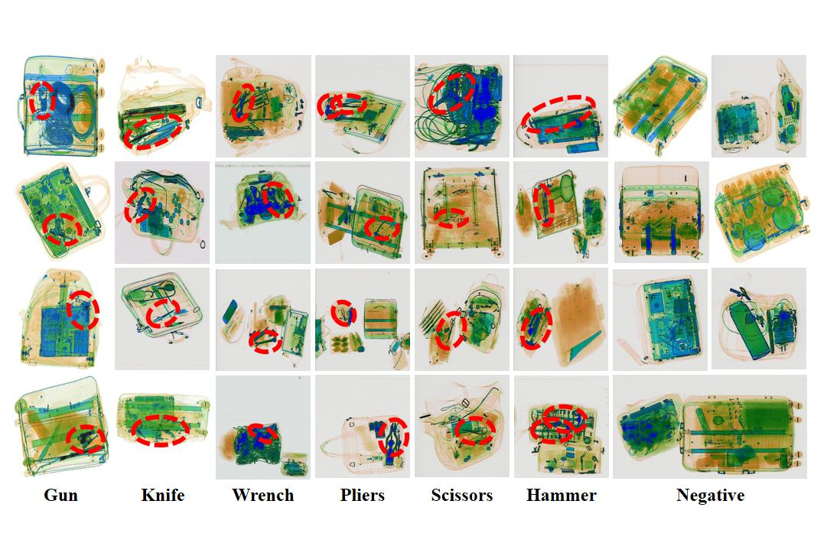

These studies collectively underline the complexity of prohibited item detection in X-ray images and the need for robust, efficient, and explainable models. The research gaps identified from these papers include the need for better handling of occlusions and overlapping objects, enhancement of model interpretability, and adaptation to real-world variations in X-ray imagery. This project aims to address these challenges by employing advanced deep learning techniques and refining the training process to achieve higher accuracy and reliability in prohibited item detection.

# Methodology

The methodology for this project was structured to address the complexities of detecting prohibited items in X-ray images using advanced deep learning techniques. The following steps summarize the methodology:

1. Dataset Preparation:

Acquisition: The SIXray dataset was chosen due to its large scale and relevance, containing images of common prohibited items in complex scenarios. The dataset was acquired through various online resources and was then uploaded to Roboflow, a platform that facilitates data handling for machine learning applications.

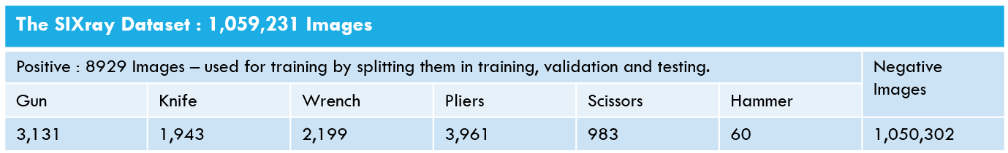

Preprocessing: Using Roboflow, the dataset was processed and prepared for training. This involved creating appropriate data splits for training, validation, and testing to ensure a comprehensive evaluation of the model.

Import Code:

import roboflow

roboflow.login()

rf = roboflow.Roboflow()

project = rf.workspace("val-didar-singh").project("xray-prohibited-object-detection")

version = project.version(1)

dataset = version.download("yolov9")

1. Model Configuration and Training:

Environment Setup: The project utilized YOLOv9, configured and executed within a designated environment to optimize resource usage and model performance.

Training Command:

%cd {HOME}/yolov9

!python train.py --batch 16 --epochs 30 --img 320 --device 0 --min-items 0 --close-mosaic 15 \

--data {dataset.location}/data.yaml \

--weights {HOME}/weights/gelan-c.pt \

--cfg models/detect/gelan-c.yaml \

--hyp hyp.scratch-high.yaml

Parameters: The model was trained with specific parameters set to optimize the learning process, including batch size, number of epochs, image resolution, and data augmentation techniques such as close mosaic to enhance the model's ability to generalize from complex input data.

1. Technology Stack:

Deep Learning Framework: YOLOv9, known for its efficiency and effectiveness in object detection tasks.

Computational Resources: Utilized GPU acceleration to handle the computational demands of training deep neural networks.

This methodology was carefully designed to leverage the capabilities of deep learning to detect prohibited items with high accuracy and speed, ensuring the model's applicability in real-world security scenarios.

# Results

The Confusion matrix of the 5 classes after 30 epochs of training using the YOLO model are presented below:

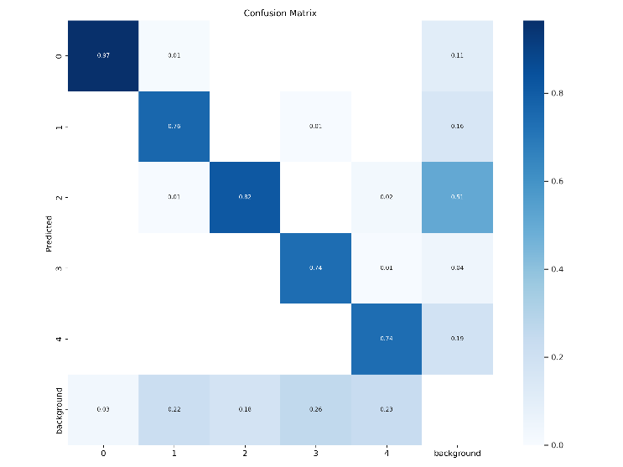

Also apart from this, a table of the underlying Parameters were also calculated, of each class separately and all classes combined.

1. P (Precision):

Measures the proportion of correctly predicted positive instances among all predicted positive instances. Perfect precision (P=1) means no false positives.

1. R (Recall):

Measures the proportion of correctly predicted positive instances among all actual positive instances. Perfect recall (R=1) means no false negatives.

1. mAP50 (Mean Average Precision at IoU=0.50):

Average precision across different classes at an IoU (Intersection over Union) threshold of 0.50. Perfect mAP50 (mAP50=1) indicates perfect object detection at that threshold.

1. mAP50-95 (Mean Average Precision from IoU=0.50 to IoU=0.95):

Average precision across different classes over a range of IoU thresholds from 0.50 to 0.95. Perfect mAP50-95 (mAP50-95=1) indicates consistent and accurate object detection across all IoU thresholds within the specified range.

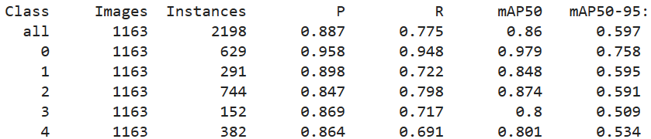

You can also see the improvement of results after each epoch with the following graph of various looses calculated for each epoch.

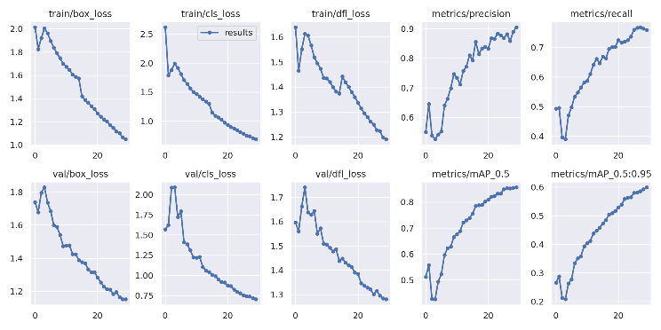

These results demonstrate the model's effectiveness, particularly in detecting guns with high precision and recall. The varying performance across different classes underscores the challenges associated with specific item detection in cluttered and overlapping scenarios. The detailed metrics provide insights into the model's strengths and areas for improvement, guiding future enhancements and applications of the technology.

# Discussion

This section interprets the significance of the results obtained and discusses the broader implications for the field of X-ray security imaging.

1. Interpretation of Results:

The model demonstrated high precision and recall, especially in detecting guns (example detection showcased in the picture provided below, which is crucial for security applications. This indicates that the YOLOv9 model, tailored with specific training strategies, is highly effective for recognizing more conspicuous prohibited items within X-ray images.

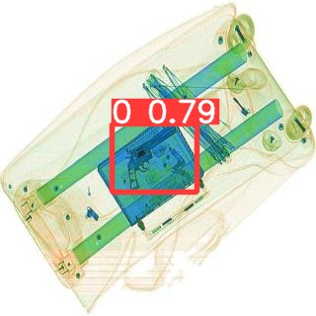

However, the lower performance metrics for items like knives and pliers suggest difficulties in detecting smaller or less distinct objects, which can blend into their surroundings or get occluded by other items.

1. Challenges and Limitations:

Data Limitations: The inherent challenges of the SIXray dataset, including image clutter and object overlap, pose significant hurdles in model training and performance.

Model Limitations: While the YOLOv9 model excels in many aspects, its ability to generalize to less common or more complex object shapes and arrangements could be further improved.

1. Implications for Future Research:

Improved Object Recognition: Future research could focus on enhancing the model's ability to distinguish between closely situated or overlapping objects, potentially through more sophisticated neural network architectures or advanced preprocessing techniques.

Explainability and Trust: Incorporating techniques like Layer-wise Relevance Propagation (LRP) could make model decisions more transparent, increasing trustworthiness and deployability in security-sensitive environments.

# Conclusion

The project successfully demonstrates the application of YOLOv9 for detecting prohibited items in X-ray images, achieving notable success rates across various metrics. The study's findings contribute significantly to the ongoing efforts in enhancing security measures through advanced imaging and AI technologies. The model's high performance in detecting specific prohibited items like guns underscores its potential utility in real-world security systems, where rapid and accurate threat detection is paramount.

Summary of Findings:

1. The YOLOv9 model, customized and trained on the SIXray dataset, has proven effective, with an overall mAP50 of 0.776, showcasing its capability in practical security applications.
2. The research highlights key areas for improvement, particularly in enhancing detection accuracy for smaller or more occluded objects.

Final Thoughts:

This project not only advances the technological capabilities in the field of security imaging but also opens up avenues for further research into more robust, accurate, and trustworthy AI-driven security systems.

# Reference

1. SIXray: A Large-scale Security Inspection X-ray Benchmark for Prohibited Item Discovery in Overlapping Images. Accessed 2 Jan 2019.
2. Towards Best Practice in Explaining Neural Network Decisions with LRP. Accessed 22 Oct 2019.
3. Occluded Prohibited Items Detection: an X-ray Security Inspection Benchmark and De-occlusion Attention Module. Accessed 18 Apr 2020.
4. Over-sampling De-occlusion Attention Network for Prohibited Items Detection in Noisy X-ray Images. Accessed 1 Mar 2021.
5. Towards Real-World Prohibited Item Detection: A Large-Scale X-ray Benchmark. Accessed 16 Aug 2021.
6. PIDray: A Large-scale X-ray Benchmark for Real-World Prohibited Item Detection. Accessed 19 Nov 2022.
7. Detecting Overlapping Objects in X-ray Security Imagery by a Label-aware Mechanism. Accessed 28 Feb 2022.
8. Rethinking Few-Shot Object Detection on a Multi-Domain Benchmark. Accessed 22 Jul 2022.
9. A Novel Incremental Learning Driven Instance Segmentation Framework to Recognize Highly Cluttered Instances of the Contraband Items.